**Midterm Report**

**2020. 11. 02.**

Please submit the “Midterm Report” by 6 Nov.

1. Predict the product(s) for each reaction below. In each case, draw the resonance forms of the intermediate to explain the observed regiochemistry.

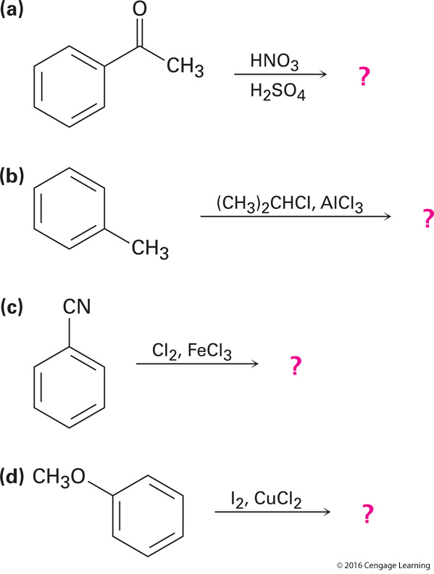

2. What Grignard reagent and what carbonyl compound might you start with to prepare the following alcohols?

